Course: Design Analysis And Algorithm Name: Dharshana D
Code: CSA0606 Regno:192524243
Date:05.10.2026 Slot: B
Session-4 Lab Programs

14.
s = input()
res = []
i = 0
while i < len(s):
j = i
while j < len(s) and s[i] == s[j]:
j += 1
if j - i >= 3:
res.append([i, j - 1])
i = j
print(res)
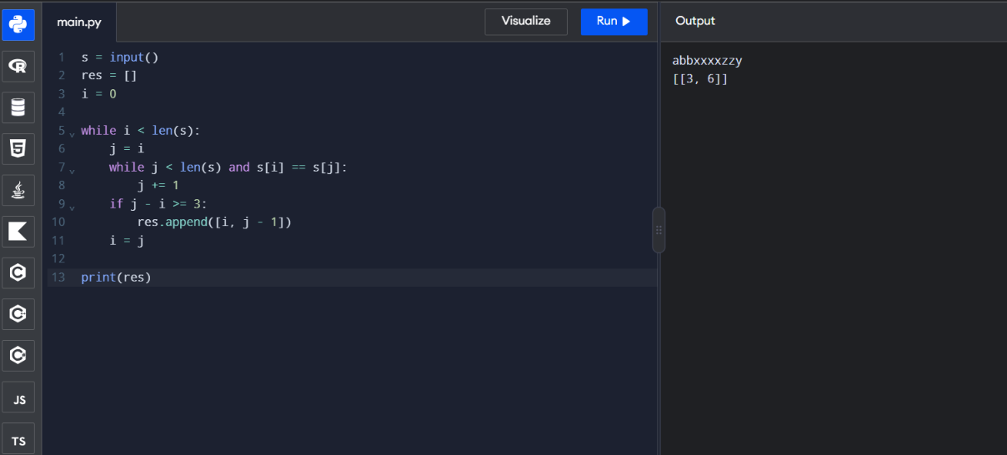
15.
board = [[0,1,0],[0,0,1],[1,1,1],[0,0,0]]
m = len(board)
n = len(board[0])
res = [[0]*n for _ in range(m)]
for i in range(m):
for j in range(n):
count = 0
for x in range(max(0,i-1), min(m,i+2)):
for y in range(max(0,j-1), min(n,j+2)):
if (x,y) != (i,j):
count += board[x][y]
if board[i][j] == 1 and count in [2,3]:
res[i][j] = 1
elif board[i][j] == 0 and count == 3:
res[i][j] = 1
print(res)

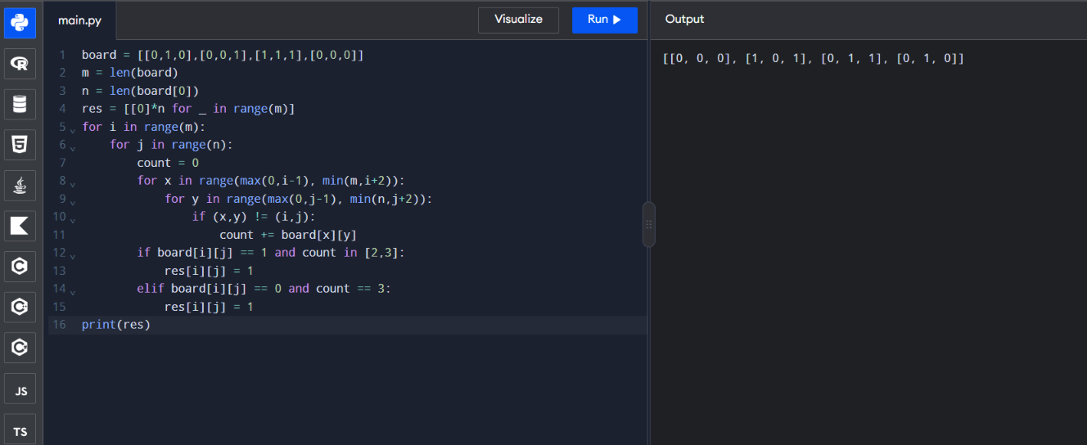
15.
poured = 2
query_row = 1
query_glass = 1
dp = [[0.0] * 101 for _ in range(101)]
dp[0][0] = poured
for i in range(query_row):
for j in range(i + 1):
if dp[i][j] > 1:
extra = (dp[i][j] - 1) / 2
dp[i + 1][j] += extra
dp[i + 1][j + 1] += extra
print(min(1.0, dp[query_row][query_glass]))

